

CyPERS
Project Management Plan v1.0



June 9, 2010
Authored by:
Ignis Technology Solutions Private Ltd.
Copyright © 2010 Ignis Technology Solutions Pvt. Ltd.
Information contained in this document is classified Ignis Technology Solutions Private Ltd. Confidential Proprietary. Only authorized Ignis Technology Solutions Private Ltd. personnel shall have access to the information contained in this document unless business needs dictate, otherwise. It is the responsibility of the person knowing the information contained in this document to ensure confidentiality of information contained in it and securing this document from unauthorized access at all times.

DOCUMENT INFORMATION
Author | Ajay Agrawal
Reviewer | Krishna Swain
Approver | Krishna Swain
Approved Date | June 22, 2010

CHANGE HISTORY
Version # | Release Date | Sections Changed | Author | Change Description
1.0 | June 22, 2010 | All | Ajay Agrawal | Final Version

Table of Contents

1. Introduction 4
2. objective 4
3. Project Management Approach 4
4. Scope Management Plan 4
4.1. Introduction 4
4.2. Scope Management Approach 4
4.3. Roles and Responsibilities 4
4.4. Scope Definition 5
4.5. Project Scope Statement 6
4.6. Work Breakdown Structure 6
4.7. Scope Verification 6
4.8. Scope Control 6
5. Milestone List 7
6. Schedule Management Plan 7
6.1. Introduction 7
6.2. Schedule Management Approach 7
6.3. Schedule Control 8
6.4. Schedule Changes and Thresholds 8
6.5. Scope Change 9
7. Cost Management Plan 10
7.1. Introduction 10
7.2. Cost Management Approach 10
7.3. Measuring Project Costs Reporting Format 10
7.4. Cost Variance Response Process 11
7.5. Cost Change Control Process 11
7.6. Project Budget 11
8. Staffing Management Plan 11
9.1. Project Competency Requirement 11
9.2. Roles & Responsibility 12
9.3. Project Organization Chart 13
9. Quality Management Plan 14
10. Risk management plan 15
11.1. Introduction 15
11.2. Top Three Risks 16
11.3. Risk Management Approach 16
11.4. Risk Identification 16
11.5. Risk Qualification and Identification 16
11.6. Risk Monitoring 17
11.7. Risk Mitigation and Avoidance 17
11.8. Risk Register 17
11. Resource Calendar 18
12. Communication Management Plan 18
13.1. Introduction 18
13.2. Communications Management Approach 18
13.3. Roles 18
13.4. Project Team Directory 19
13.5. Communications Matrix 0
13.6. Guidelines for Meetings 0
13. Project Change Control Process 0
14. Schedule Baseline and Work Breakdown Structure 1
15. Configuration management plan 1
16. Hardware & Software Requirement 1
19.1. General Requirements 1
19.2. Browser Requirements 1
19.3. Hardware Requirement for Development 1
19.4. Hardware Requirement for Server 2
17. Project Close-Out Plan 2

Introduction
CyPERS is a web-based Electronic Medical Record to be used by Direct Patient Care Providers. This document describes the management approach for managing the CyPERS project. This document can be change and modified by the project manager based on the situation and need with the approval of Project sponsor and project stockholders.

objective
- To Develop a web based solution to manage the Patient information electronically
- Registered hospital should be able to manage their patient information locally.
- Central Repository for all registered Hospital data.
- Data transmission between hospitals should be based on HL7 specification.

Project Management Approach
For CyPERS project the development methodology would be agile development Process.

Scope Management Plan

Introduction
The Scope Management Plan provides the scope framework for this project. This plan describes the scope management approach; roles and responsibilities as they pertain to project scope; scope definition; verification and control measures; scope change control; and the project’s work breakdown structure. Any project communication which pertains to the project’s scope should adhere to the Scope Management Plan.

Scope Management Approach
For this project, scope management will be the sole responsibility of the Project Manager. The scope for this project is defined by the Scope Statement, Work Breakdown Structure (WBS) and WBS Dictionary. The Project Manager, Sponsor and Stakeholders will establish and approve documentation for measuring project scope which includes deliverable quality checklists and work performance measurements. Proposed scope changes may be initiated by the Project Manager, Stakeholders or any member of the project team. All change requests will be submitted to the Project Manager who will then evaluate the requested scope change. Upon acceptance of the scope change request the Project Manager will submit the scope change request to the Change Control Board and Project Sponsor for acceptance. Upon approval of scope changes by the Change Control Board and Project Sponsor the Project Manager will update all project documents and communicate the scope change to all stakeholders. Based on feedback and input from the Project Manager and Stakeholders, the Project Sponsor is responsible for the acceptance of the final project deliverables and project scope.

Roles and Responsibilities
The Project Manager, Sponsor and team will all play key roles in managing the scope of this project. As such, the project sponsor, manager, and team members must be aware of their responsibilities in order to ensure that work performed on the project is within the established scope throughout the entire duration of the project. The table below defines the roles and responsibilities for the scope management of this project.
Role | Responsibilities
Sponsor | - Approve or deny scope change requests as appropriate  - Evaluate need for scope change requests  - Accept project deliverables
Project Manager | - Measure and verify project scope  - Facilitate scope change requests  - Facilitate impact assessments of scope change requests  - Organize and facilitate scheduled change control meetings  - Communicate outcomes of scope change requests
Business Analyst | - Update project documents upon approval of all scope changes  - Facilitate impact assessments of scope change requests  - Measure and verify project scope  - Facilitate scope change requests
Team Lead | - Measure and verify project scope  - Validate scope change requests  - Participate in impact assessments of scope change requests  - Communicate outcomes of scope change requests to team  - Facilitate team level change review process
Team Member | - Participate in defining change resolutions  - Evaluate the need for scope changes and communicate them to the project manager as necessary
Table 1.1, Scope Management Roles and Responsibilities

Scope Definition
The scope for this project was defined through a comprehensive requirements collection process. First, a thorough analysis & requirement collection was performed with the project stakeholder and sponsor. From this information, the project team developed the project requirements documentation, the requirements management plan, and the requirements traceability matrix for what the new software application must accomplish.
The project description and deliverables were developed based on the requirements collection process and input from subject matter experts in software design, technical support, programming and business applications.

Project Scope Statement
Below is the URL for the Project Scope Statement Document.
http://192.168.1.11/pmo/Document%20Library/CyPERS/System%20Requirement/CyPERS%20Software%20Requirements%20document%20V1.0.doc
Below is the URL for requirement traceability matrix
http://58.68.4.21/pmo/Document%20Library/CyPERS/Initiation%20And%20Planning/Requirements%20Traceability%20Matrix.xls

Work Breakdown Structure
Work Breakdown structure is available in the Microsoft project 2007. Below is the URL for the Microsoft Project file.
http://192.168.1.11/pmo/Document%20Library/CyPERS/Initiation%20And%20Planning/CyPERS.mpp

Scope Verification
As this project progresses the Project Manager will verify interim project deliverables against the original scope as defined in the scope statement, WBS and WBS Dictionary. Once the Project Manager verifies that the scope meets the requirements defined in the project plan, the Project Manager and Sponsor will meet for formal acceptance of the deliverable. During this meeting the Project Manager will present the deliverable to the Project Sponsor for formal acceptance. The Project Sponsor will accept the deliverable by signing a project deliverable acceptance document. This will ensure that project work remains within the scope of the project on a consistent basis throughout the life of the project.

Scope Control
The Project Manager and the project team will work together to control of the scope of the project. The project team will leverage the Use case by using it as a statement of work for each WBS element. The project team will ensure that they perform only the work described in the scope document and generate the defined deliverables for each WBS element. The Project Manager will oversee the project team and the progression of the project to ensure that this scope control process if followed.
If a change to the project scope is needed the process for recommending changes to the scope of the project must be carried out. Any project team member or sponsor can request changes to the project scope. All change requests must be submitted to the Project Manager/Business Analyst in the form of a project change request document. The Project Manager/Business Analyst will then review the suggested change to the scope of the project. The Project Manager with discussion with business analyst will then either deny the change request if it does not apply to the intent of the project or convene a change control meeting between the project team and Sponsor to review the change request further and perform an impact assessment of the change. If the change request receives initial approval by the Project Manager and Sponsor, the Project Manager will then formally submit the change request to the Change Control Board. If the Change Control Board approves the scope change the Project Sponsor will then formally accept the change by signing the project change control document. Upon acceptance of the scope change by the Change Control Board and Project Sponsor the Project Manager will update all project documents and communicate the scope change to all project team members’ stakeholders.

Milestone List
Milestone | Description | Date

Schedule Management Plan

Introduction
The project schedule is the roadmap for how the project will be executed. Schedules are an important part of any project as they provide the project team, sponsor, and stakeholders a picture of the project’s status at any given time. The purpose of the schedule management plan is to define the approach the project team will use in creating the project schedule. This plan also includes how the team will monitor the project schedule and manage changes after the baseline schedule has been approved. This includes identifying, analyzing, documenting, prioritizing, approving or rejecting, and publishing all schedule-related changes.

Schedule Management Approach
Project schedules will be created using MS Project 2007 starting with the deliverables identified in the project’s Work Breakdown Structure (WBS). Activity definition will identify the specific work packages which must be performed to complete each deliverable. Activity sequencing will be used to determine the order of work packages and assign relationships between project activities. Activity duration estimating will be used to calculate the number of work periods required to complete work packages. Resource estimating will be used to assign resources to work packages in order to complete schedule development.
Once a preliminary schedule has been developed, it will be reviewed by the project team and any resources tentatively assigned to project tasks. The project team and resources must agree to the proposed work package assignments, durations, and schedule. Once this is achieved the project sponsor will review and approve the schedule and it will then be baseline.
The following will be designates as milestones for the project schedule:
- Completion of scope statement and WBS/WBS Dictionary
- Baseline project schedule
- Approval of final project budget
- Project kick-off
- Approval of roles and responsibilities
- Requirements definition approval
- Completion of data mapping/inventory
- Project implementation
- Acceptance of final deliverables

Roles and responsibilities for schedule development are as follows:
The project manager will be responsible for facilitating work package definition, sequencing, and estimating duration and resources with the project team. The project manager will also create the project schedule using MS Project 2007 and validate the schedule with the project team, stakeholders, and the project sponsor. The project manager will obtain schedule approval from the project sponsor and baseline the schedule.
The project team is responsible for participating in work package definition, sequencing, and duration and resource estimating. The project team will also review and validate the proposed schedule and perform assigned activities once the schedule is approved.
The project sponsor will participate in reviews of the proposed schedule and approve the final schedule before it is baseline.
The project stakeholders will participate in reviews of the proposed schedule and assist in its validation.

Schedule Control
The project schedule will be reviewed and updated as necessary on a bi-weekly basis with actual start, actual finish, and completion percentages which will be provided by task owners.
The project manager is responsible for holding bi-weekly schedule updates/reviews; determining impacts of schedule variances; submitting schedule change requests; and reporting schedule status in accordance with the project’s communications plan.
The project team is responsible for participating in bi-weekly schedule updates/reviews; communicating any changes to actual start/finish dates to the project manager; and participating in schedule variance resolution activities as needed.
The project sponsor will maintain awareness of the project schedule status and review/approve any schedule change requests submitted by the project manager.

Schedule Changes and Thresholds
If any member of the project team determines that a change to the schedule is necessary, the project manager and team will meet to review and evaluate the change. The project manager and project team must determine which tasks will be impacted, variance as a result of the potential change, and any alternatives or variance resolution activities they may employ to see how they would affect the scope, schedule, and resources. If, after this evaluation is complete, the project manager determines that any change will exceed the established boundary conditions, then a schedule change request must be submitted.
Submittal of a schedule change request to the project sponsor for approval is required if either of the two following conditions is true:
- The proposed change is estimated to reduce the duration of an individual work package by 10% or more, or increase the duration of an individual work package by 10% or more.
- The change is estimated to reduce the duration of the overall baseline schedule by 10% or more, or increase the duration of the overall baseline schedule by 10% or more.
Any change requests that do not meet these thresholds may be submitted to the project manager for approval.
Once the change request has been reviewed and approved the project manager is responsible for adjusting the schedule and communicating all changes and impacts to the project team, project sponsor, and stakeholders. The project manager must also ensure that all change requests are archived in the project records repository.

Scope Change
Any changes in the project scope, which have been approved by the project sponsor, will require the project team to evaluate the effect of the scope change on the current schedule. If the project manager determines that the scope change will significantly affect the current project schedule, he/she may request that the schedule be re-baselined in consideration of any changes which need to be made as part of the new project scope. The project sponsor must review and approve this request before the schedule can be re-baselined.
Below is the process diagram for the business analyst/project manager to ensure the scope of work.
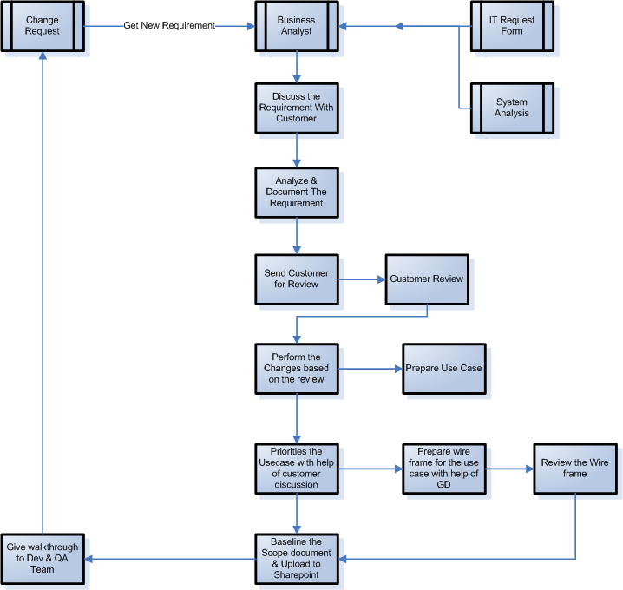

Cost Management Plan

Introduction
The Project Manager will be responsible for managing and reporting on the project’s cost throughout the duration of the project. During the monthly project status meeting, the Project Manager will meet with management to present and review the project’s cost performance for the preceding month. Performance will be measured using earned value. The Project Manager is responsible for accounting for cost deviations and presenting the Project Sponsor with options for getting the project back on budget. The Project Sponsor has the authority to make changes to the project to bring it back within budget.

Cost Management Approach
Costs for this project will be managed at the fourth level of the Work Breakdown Structure (WBS). Control Accounts (CA) will be created at this level to track costs. Earned Value calculations for the CA’s will measure and manage the financial performance of the project. Although activity cost estimates are detailed in the work packages, the level of accuracy for cost management is at the fourth level of the WBS. Credit for work will be assigned at the work package level. Work started on work packages will grant that work package with 50% credit; whereas, the remaining 50% is credited upon completion of all work defined in that work package. Costs may be rounded to the nearest dollar and work hours rounded to the nearest whole hour.
Cost variances of +/- 0.1 in the cost and schedule performance indexes will change the status of the cost to cautionary; as such, those values will be changed to yellow in the project status reports. Cost variances of +/- 0.2 in the cost and schedule performance indexes will change the status of the cost to an alert stage; as such, those values will be changed to red in the project status reports. This will require corrective action from the Project Manager in order to bring the cost and/or schedule performance indexes below the alert level. Corrective actions will require a project change request and be must approved by the Project Sponsor before it can become within the scope of the project.

Measuring Project Costs Reporting Format
Performance of the project will be measured using Earned Value Management. The following four Earned Value metrics will be used to measure to projects cost performance:
- - Schedule Variance (SV)
- - Cost Variance (CV)
- - Schedule Performance Index (SPI)
- - Cost Performance Index (CPI)
If the Schedule Performance Index or Cost Performance Index has a variance of between 0.1 and 0.2 the Project Manager must report the reason for the exception. If the SPI or CPI has a variance of greater than 0.2 the Project Manager must report the reason for the exception and provide management a detailed corrective plan to bring the projects performance back to acceptable levels.
Performance Measure | Yellow | Red
Schedule Performance Index (SPI) | Between 0.9 and 0.8 or Between 1.1 and 1.2 | Less Than 0.8 or Greater than 1.2
Cost Performance Index (CPI) | Between 0.9 and 0.8 or Between 1.1 and 1.2 | Less Than 0.8 or Greater than 1.2

The variance in project will be calculated in the Microsoft project 2007.

Cost Variance Response Process
Reporting for cost management will be included in the monthly project status report. The Monthly Project Status Report will include a section labeled, “Cost Management”. This section will contain the Earned Value Metrics identified in the previous section. All cost variances outside of the thresholds identified in this Cost Management Plan will be reported on including any corrective actions which are planned. Change Requests which are triggered based upon project cost overruns will be identified and tracked in this report.

Cost Change Control Process
The Control Thresholds for this project is a CPI or SPI of less than 0.8 or greater than 1.2. If the project reaches one of these Control Thresholds a Cost Variance Corrective Action Plan is required. The Project Manager will present the Project Sponsor with options for corrective actions within five business days from when the cost variance is first reported. Within three business days from when the Project Sponsor selects a corrective action option, the Project Manager will present the Project Sponsor with a formal Cost Variance Corrective Action Plan. The Cost Variance Corrective Action Plan will detail the actions necessary to bring the project back within budget and the means by which the effectiveness of the actions in the plan will be measured. Upon acceptance of the Cost Variance Corrective Action Plan it will become a part of the project plan and the project will be updated to reflect the corrective actions.

Project Budget
The budget for this project is detailed below. Costs for this project are presented in various categories...
Fixed Costs:
Material Costs:
Contractor Costs:
Total Project Cost:
Management Reserve:

Staffing Management Plan
The resource for this project will be hired or taken from the existing talent pool of Ignis technology based on the Project Specific Competency Requirement document for this project with the consent of Chief Technical Officer of Ignis Technology. Project Manager will raise a Resource Requisition request to HR department for the resource hiring.

Project Competency Requirement
Below is the URL for the Project competency Requirement document.
http://192.168.1.11/pmo/Document%20Library/CyPERS/Initiation%20And%20Planning/project_resouce_requirement.xls

Roles & Responsibility
Project Manager
The role of a Project Manager in team is to lead the project team with structured project management methodologies and take ownership for completion of assigned projects within budgetary and scheduling guidelines.
Technical Architect
The role of Java Technical Architect is to lead the process of converting business requirements into an architecture and design which will become a blueprint for the solution being created.
Business Analyst
Translate business requirements to functional specifications and assist the Business Users in making scope decisions by providing information on trade-off between cost, time, complexity and usability.
Quality Team
Ensure that testing activities will allow applications to meet business requirements and systems goals, fulfill end-user requirements, and identify and resolve systems issues.
Software Engineer
The Java Programmer is the part of the core development team and be responsible for the development of the Product / Applications CyPERS.

Project Organization Chart

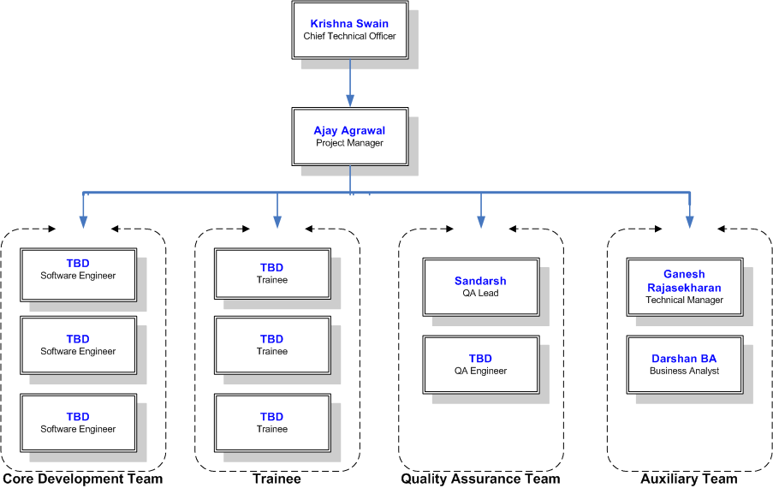

Quality Management Plan
Team will use the BUGZILLA tool for the Bug tracking in the application. Below is the workflow for the Bug Tracking.
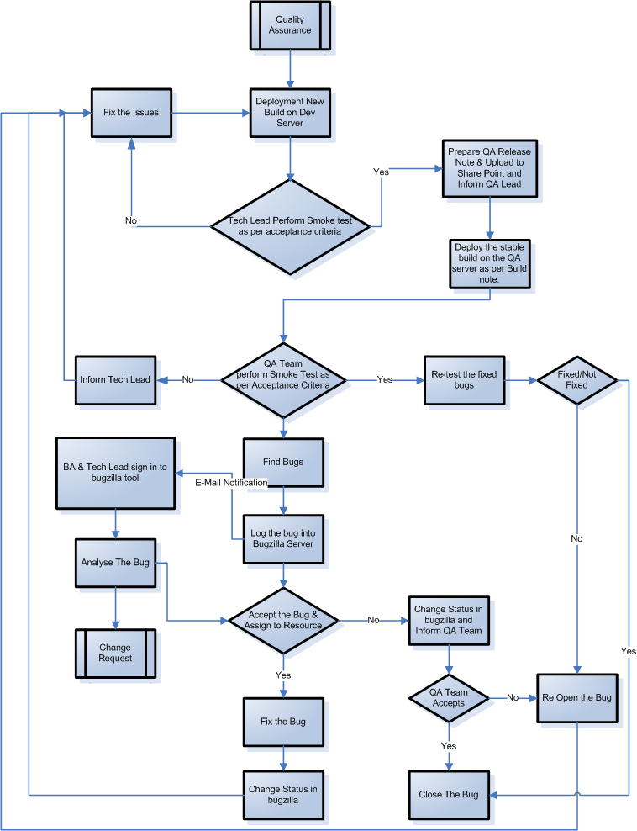

By end of every testing cycle, project manager will do the bug analysis with the help of cause and effect diagram. Based on the output project manager can take any preventive or corrective action to ensure the better quality of application and for the process improvement.
Below is the URL for the Test Plan.
<URL>

Risk management plan

Introduction
As organizations begin new projects they begin operating in an area of uncertainty that comes along with developing new and unique products or services. By doing so, these organizations take chances which results in risk playing a significant part in any project. The purpose of the risk management plan is to establish the framework in which the project team will identify risks and develop strategies to mitigate or avoid those risks. However, before risks can be identified and managed, there are preliminary project elements which must be completed. These elements are outlined in the risk management approach.
This project is considered a medium risk project as it has an overall risk score of 24 on a scale from 0 to 100. The project risk score is the average of the risk scores of the most significant risks to this project. A risk score below 16 is low risk project, a score between 16 and 45 is a medium risk project and a score above 45 is a high risk project.
Before risk management begins it is imperative that a foundation is established for providing structured project information, thus, the following project elements were completed and defined prior to developing this Risk Management Plan:
- Define work scope, schedule, resources, and cost elements
  - Develop project WBS/WBS dictionary
  - Develop master schedule and detailed schedules
  - Estimate project cost and finalize budget
  - Identify required and available resources
  - Establish performance measurement metrics

- Define minimum and maximum baseline thresholds
  - Schedule
  - Resources
  - Cost

- Baseline reporting requirements
  - Format
  - Frequency of distribution
  - Distribution list

- Define Risk Management Roles and Responsibilities
  - Project Manager chairs the risk assessment meetings
  - Project team participates in risk assessment meetings and members serve as meeting recorder and timekeeper
  - Key stakeholders participate in risk assessment meetings
  - Project Sponsor may participate in risk assessment meetings

Risk Management Approach
The approach we have taken to manage risks for this project included a methodical process by which the project team identified, scored, and ranked the various risks. The most likely and highest impact risks were added to the project schedule to ensure that the assigned risk managers take the necessary steps to implement the mitigation response at the appropriate time during the schedule. Risk managers will provide status updates on their assigned risks in the bi-weekly project team meetings, but only when the meetings include their risk’s planned timeframe. Upon the completion of the project, during the closing process, the project manager will analyze each risk as well as the risk management process. Based on this analysis, the project manager will identify any improvements that can be made to the risk management process for future projects. These improvements will be captured as part of the lessons learned knowledge base.

Risk Identification
For this project, risk identification was conducted in the initial project risk assessment meeting. The method used by the project team to identify risks was the Crawford Slip method. The project manager chaired the risk assessment meeting and distributed notepads to each member of the team and allowed 10 minutes for all team members to record as many risks as possible.
Expert Interview
Two Expert Interviews were held for this project. The interviews revealed several risks which were then mitigated by making changes to the project plan. The remaining risks are included in the Risk Register.
Risk Assessment Meeting
A risk assessment meeting was held with key team members and stakeholders. The risks identified during this meeting were added to the project plan and Risk Register.
Historical Review of Similar Projects
The project team reviewed the history of similar projects in order to determine the most common risks and the strategies used to mitigate those risks.

Risk Qualification and Identification
In order to determine the severity of the risks identified by the team, a probability and impact factor was assigned to each risk. This process allowed the project manager to prioritize risks based upon the effect they may have on the project. The project manager utilized a probability-impact matrix to facilitate the team in moving each risk to the appropriate place on the chart.
Once the risks were assigned a probability and impact and placed in the appropriate position on the chart, the recorder captured the finished product and the project manager moved the process on to the next step: risk mitigation/avoidance planning.

Risk Monitoring
The most likely and greatest impact risks have been added to the project plan to ensure that they are monitored during the time the project is exposed to each risk. At the appropriate time in the project schedule a Risk Manager is assigned to each risk. During the bi-weekly project team meeting the Risk Manager for each risk will discuss the status of that risk; however, only risks which fall in the current time period will be discussed. Risk monitoring will be a continuous process throughout the life of this project. As risks approach on the project schedule the project manager will ensure that the appropriate risk manager provides the necessary status updates which include the risk status, identification of trigger conditions, and the documentation of the results of the risk response.

Risk Mitigation and Avoidance
The project manager has led the project team in developing responses to each identified risk. As more risks are identified, they will be qualified and the team will develop avoidance and mitigation strategies. These risks will also be added to the Risk Register and the project plan to ensure they are monitored at the appropriate times and are responded to accordingly.
The risks for this project will be managed and controlled within the constraints of time, scope, and cost. All identified risks will be evaluated in order to determine how they affect this triple constraint. The project manager, with the assistance of the project team, will determine the best way to respond to each risk to ensure compliance with these constraints.
In extreme cases it may be necessary to allow flexibility to one of the project’s constraints. Only one of the constraints for this project allows for flexibility as a last resort. If necessary, funding may be added to the project to allow for more resources in order to meet the time (schedule) and scope constraints. Time and scope are firm constraints and allow for no flexibility. Again, the cost constraint is flexible only in extreme cases where no other risk avoidance or mitigation strategy will work.

Risk Register
The Risk Register for this project is a log of all identified risks, their probability and impact to the project, the category they belong to, mitigation strategy, and when the risk will occur. The register was created through the initial project risk management meeting led by the project manager. During this meeting, the project team identified and categorized each risk. Additionally, the team assigned each risk a score based on the probability of it occurring and the impact it could potentially have. The Risk Register also contains the mitigation strategy for each risk as well as when the risk is likely to occur.
Based on the identified risks and timeframes in the risk register, each risk has been added to the project plan. At the appropriate time in the plan—prior to when the risk is most likely to occur—the project manager will assign a risk manager to ensure adherence to the agreed upon mitigation strategy. The each risk manager will provide the status of their assigned risk at the bi-weekly project team meeting for their risk’s planned timeframe.
Below is the URL for the Risk Register:
http://192.168.1.11/pmo/Document%20Library/CyPERS/Risk%20Analysis/Risk%20Register.xls

Resource Calendar
Resource Calendar is a part of Microsoft project 2007. The resource calendar identifies key resources needed for the project and the times/durations they'll be needed.

Communication Management Plan

Introduction
This Communications Management Plan sets the communications framework for this project. It will serve as a guide for communications throughout the life of the project and will be updated as communication needs change. This plan identifies and defines the roles of persons involved in this project. It also includes a communications matrix which maps the communication requirements of this project. An in-depth guide for conducting meetings details the communications rules and how the meetings will be conducted, ensuring successful meetings. A project team directory is included to provide contact information for all stakeholders directly involved in the project.

Communications Management Approach
The Project Manager will take a proactive role in ensuring effective communications on this project. The communications requirements are documented in the Communications Matrix presented in this document. The Communications Matrix will be used as the guide for what information to communicate, who is to do the communicating, when to communicate it and to whom to communicate.

Roles

    - Project Sponsor
The project sponsor is the champion of the project and has authorized the project by signing the project charter. This person is responsible for the funding of the project and is ultimately responsible for its success. Since the Project Sponsor is at the executive level communications should be presented in summary format unless the Project Sponsor requests more detailed communications.
    - Program Manager
The Program Manager oversees the project at the portfolio level and owns most of the resources assigned to the project. The Program Manager is responsible for overall program costs and profitability as such they require more detailed communications than the Project Sponsor.
    - Key Stakeholders
Normally Stakeholders includes all individuals and organizations that are impacted by the project. For this project we are defining a subset of the stakeholders as Key Stakeholders. These are the stakeholders with whom we need to communicate with and are not included in the other roles defined in this section. The Key Stakeholders includes executive management with an interest in the project and key users identified for participation in the project.
    - Change Control Board
The Change Control Board is a designated group which is reviews technical specifications and authorizes changes within the organizations infrastructure. Technical design documents, user impact analysis and implementation strategies are typical of the types of communication this group requires.
    - Customer
The customer for this project is Dr. Umesh Gupta. As the customer who will be accepting the final deliverable of this project they will be informed of the project status including potential impacts to the schedule for the final deliverable or the product itself.
    - Project Manager
The Project Manager has overall responsibility for the execution of the project. The Project Manager manages day to day resources, provides project guidance and monitors and reports on the projects metrics as defined in the Project Management Plan. As the person responsible for the execution of the project, the Project Manager is the primary communicator for the project distributing information according to this Communications Management Plan.
    - Project Team
The Project Team is comprised of all persons who have a role performing work on the project. The project team needs to have a clear understanding of the work to be completed and the framework in which the project is to be executed. Since the Project Team is responsible for completing the work for the project they played a key role in creating the Project Plan including defining its schedule and work packages. The Project Team requires a detailed level of communications which is achieved through day to day interactions with the Project Manager and other team members along with weekly team meetings.
    - Technical Lead
The Technical Lead is a person on the Project Team who is designated to be responsible for ensuring that all technical aspects of the project are addressed and that the project is implemented in a technically sound manner. The Technical Lead is responsible for all technical designs, overseeing the implementation of the designs and developing as-build documentation. The Technical Lead requires close communications with the Project Manager and the Project Team.

Project Team Directory
The following table presents contact information for all persons identified in this communications management plan. The email addresses and phone numbers in this table will be used to communicate with these people.
Role | Name | Email | Phone | Skype ID
Project Sponsor/Customer | Dr. Umesh Gupta | uhgupta@hotmail.com | +919910643222
Program Manager | Krishna Swain | Krishna.swain@ignistech.com | +919900922004 | krishcs1
Project Manager | Ajay Agrawal | Ajay.agrawal@ignistech.com | +919900185763 | ajayagrawal7785
Project Team | Anand Dhanya | Anand.dhanya@ignistech.com | +919844138991
 | Darshan BA | Darshan.ba@ignistech.com | +919900265200
 | Vinay Benchalli | Vinay.benchalli@ignistech.com | +919886763841
 | Ravindra Kundla | Ravindra.kundla@ignistech.com | +919886556346
Technical Lead | Ganesh Rajasekaran | ganesh.rajasekaran@ignistech.com

Communications Matrix
Communication Type | Objective of Communication | Medium | Frequency | Audience | Owner | Deliverable
Kickoff Meeting | Introduce the project team and the project. Review project objectives and management approach. | - Face to Face | Once | - Project Sponsor  - Project Team  - Stakeholders | Project Manager | - Agenda  - Meeting Minutes
Project Team Meetings | Review status of the project with the team. | - Face to Face  - Conference Call | Weekly | - Project Team | Project Manager | - Agenda  - Meeting Minutes
Technical Design Meetings | Discuss and develop technical design solutions for the project. | - Face to Face | As Needed | - Project Technical Staff | Technical Lead | - Agenda  - Meeting Minutes
Monthly Project Status Meetings | Report on the status of the project to management. | - Face to Face  - Conference Call | Monthly | - PMO | Project Manager | - Project Status Report
Project Status Reports | Report the status of the project including activities, progress, costs and issues. | - Email | Monthly | - Project Sponsor  - Project Team  - Stakeholders  - PMO | Project Manager | - Project Status Report

Guidelines for Meetings
Meeting Agenda
Meeting Agenda will be distributed 1 business days in advance of the meeting. The Agenda should identify the presenter for each topic along with a time limit for that topic. The first item in the agenda should be a review of action items from the previous meeting.
Meeting Minutes
Meeting minutes will be distributed within 2 business days following the meeting. Meeting minutes will include the status of all items from the agenda along with new action items.
Action Items
Action Items are recorded in both the meeting agenda and minutes. Action items will include both the action item along with the owner of the action item. Meetings will start with a review of the status of all action items from previous meetings and end with a review of all new action items resulting from the meeting. The review of the new action items will include identifying the owner for each action item.
Meeting Chair Person
The Chair Person is responsible for distributing the meeting agenda, facilitating the meeting and distributing the meeting minutes. The Chair Person will ensure that the meeting starts and ends on time and that all presenters adhere to their allocated time frames.
Note Taker
The Note Taker is responsible for documenting the status of all meeting items, maintaining a Parking Lot item list and taking notes of anything else of importance during the meeting. The Note Taker will give a copy of their notes to the Chair Person at the end of the meeting as the Chair Person will use the notes to create the Meeting Minutes.
Time Keeper
The Time Keeper is responsible for helping the facilitator adhere to the time limits set in the meeting agenda. The Time Keeper will let the presenter know when they are approaching the end of their allocated time. Typically a quick hand signal to the presenter indicating how many minutes remain for the topic is sufficient.

Project Change Control Process
Proposed scope changes may be initiated by the Project Manager, Stakeholders or any member of the project team. All change requests will be submitted to the Project Manager who will then evaluate the requested scope change. Upon acceptance of the scope change request the Project Manager will submit the scope change request to the Change Control Board and Project Sponsor for acceptance. Upon approval of scope changes by the Change Control Board and Project Sponsor the Project Manager will update all project documents and communicate the scope change to all stakeholders.

Schedule Baseline and Work Breakdown Structure
The schedule baseline and work breakdown structure (WBS) should be created in Microsoft Project 2007. The WBS can be exported from the MS Project file.

Configuration management plan
Document Management
All the project related document should be manage on the Microsoft SharePoint Server. SharePoint is a Microsoft product that manages the tasks and information of an organization with respect to their hierarchy levels.
http://192.168.1.11/pmo/default.aspx?RootFolder=%2fpmo%2fDocument%20Library%2fCyPERS&View=%7bA41CCB4A%2d1E3C%2d4BD4%2dB552%2d1CCCBCFFD2FF%7d
Source Code
All the Project source code will be manage in the CVS tool. The Concurrent Versions System (CVS), also known as the Concurrent Versioning System, is a free software revision control system in the field of software development.
CVS Repository
:pserver;username=<Username>;password=<password>;hostname=ignis-sav;port=2401:/cvsprojects/cypers
Below is the URL for the configuration plan.
http://192.168.1.11/pmo/Document%20Library/CyPERS/Initiation%20And%20Planning/Configuration%20Management%20Plan.doc

Hardware & Software Requirement

General Requirements
- Screen resolution of 1024x768 or higher
- Color depth of 16 bits-per-pixel or higher
- Reasonably fast network connection (56k modem or faster)
- A computer and operating system capable of meeting our browser requirements

Browser Requirements
- Microsoft Internet Explorer 7.0 (or later)
- Firefox 3.5 (or Later)
- Safari 4.0 (or Later)

Hardware Requirement for Development
Component | Minimum requirement
Processor | 64-bit, quad-core, 2.5 GHz per core
RAM | 2 GB for developer or evaluation installation
Hard disk | 80 GB for installation

Hardware Requirement for Server
Component | Minimum requirement
Processor | Intel Core2 Duo
RAM | 4 GB to 8GB
Hard disk | 180 to 250 GB

Project Close-Out Plan
Project close-out involves following action time.
- Release Resources
- Return Customer Supplied Material, if any
- Consolidate good practices, lesson learned
- Collect Project Metrics
- Prepare Project Closure Report
- Conduct Project Closure Meeting (Project Postmortem Analysis meeting)
- Submit Invoice Request (if any)
- Archive Documents and Source Code

Sponsor Acceptance

Approved by the Chief Technology Officer:

Date:
Krishna Swain - Chief Technology Officer (CTO)

